FOR IMMEDIATE RELEASE
Media Contacts:
Penelope C. Fletcher, Executive Director, The Branch Museum of Architecture and Design
2501 Monument Avenue, Richmond, VA 23220
(804) 655-6101
pfletcher@branchmuseum.org

Public Information: (804) 655-6055 / Branchmuseum.org

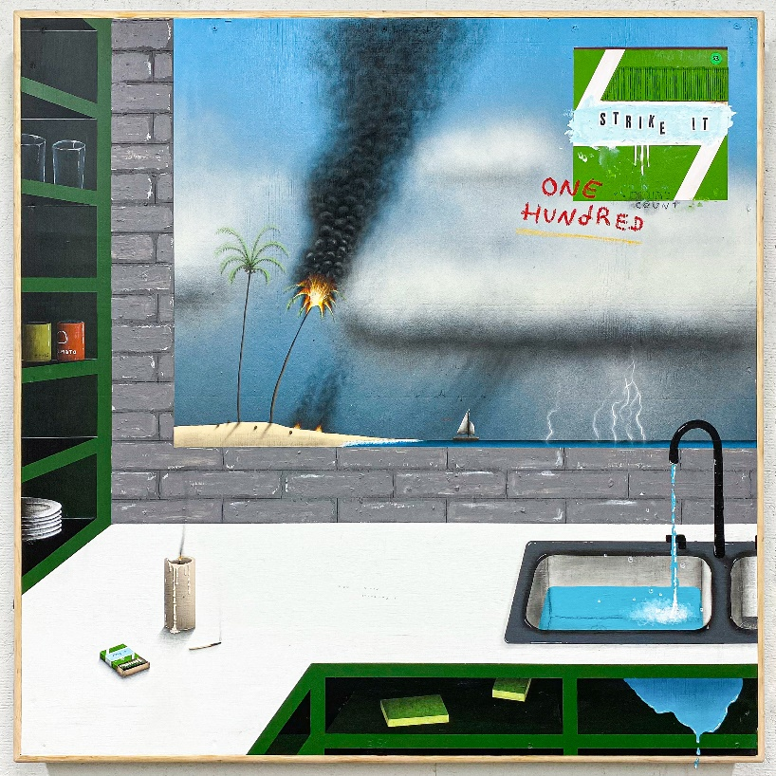

“Quality Time”

RICHMOND, VA June 4, 2021 — The Branch Museum of Architecture and Design is excited to announce a new exhibition, Quality Time (July 15th – August 20th, 2021). This exhibition brings together the diverse work of ten young artists, all Virginia Commonwealth University alumni. As many people across the globe experienced in 2020, this group of artists was separated without warning. The conclusion of their college careers didn’t quite feel like an end and all plans went awry. A year later, this exhibition marks the reunion of these artists. Although they have since scattered far and wide, their artwork can return to the city of Richmond again.
Artwork is an extension of the artist themselves - an offering of their inner thoughts to the viewer. It’s an intimate gesture of sharing. Quality Time brings together a variety of artists with equally diverse experiences reflected in their art ranging from paintings to sculptures and books to video. The artists themselves may not be able to see each other in person, but at least their work can spend some quality time together. We hope you will come to spend some time with the pieces and maybe get to know the artists while you’re at it.

In announcing the exhibition, Branch Museum Executive Director Penny Fletcher said, “As we reopen, we are reflective in thinking about so much that was missed during the pandemic. One story resonated with our team, and out of that developed what we believe is the perfect exhibition to celebrate our reopening. One of our staff members is a 2020 Graduate of VCU in Sculpture. They and their fellow art students missed much of their final senior semester last year, including the culminating event … their senior show. We at The Branch are celebrating our own reopening with ‘the show that didn’t happen’ – Quality Time. Ten young artists have reunited to produce an exhibition of their work, both from their time at VCU and what they have developed in the ensuing year. They may have scattered to other places, but their work will be able to spend some ‘quality time’ together.” Plan on joining us for the opening on July 15, or take in the exhibition that’s with us into August.
The Branch Museum of Architecture and Design is located at 2501 Monument Avenue in Richmond, Virginia's historic Fan District. The Branch Museum inspires current generations to appreciate, support and create exemplary architecture and design. The Branch is dedicated to the advocacy and stewardship of our rich regional heritage and invites the public to envision a world enriched by architecture and design. The Branch is open to the public Tuesday-Friday 10 a.m.-5 p.m.; Saturday 10 a.m.-4 p.m. Learn more at www.branchmuseum.org.
6/4/2021
###

