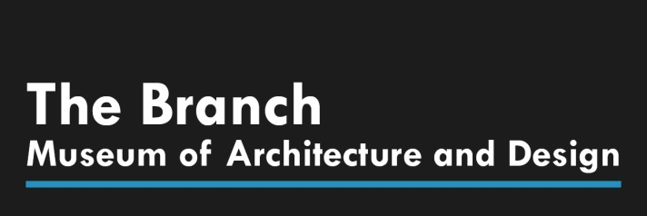

FOR IMMEDIATE RELEASE
Media Contacts:
Penny Fletcher
Executive Director, The Branch Museum of Architecture and Design
2501 Monument Avenue, Richmond, VA 23220
(804) 655-6101
pfletcher@branchmuseum.org

Public Information
(804) 655-6055
branchmuseum.org

VA Made: Meditation Across Media
RICHMOND, VA July 3, 2020 — The Branch Museum of Architecture and Design is pleased to announce VA Made: Meditation Across Media, on view from July 17th – September 13th, 2020. The exhibition brings together various artists and various forms of art. At one time, artists were learned in diverse materials and techniques. Today, artists are encouraged to narrow their focus and specialize in a specific art form. VA Made is an exhibition intended to consider the broader view of formats available to the artist. Art forms from large to small, from functional and representational will be exhibited in tandem with one another to explore the relationships between media and subject matter.
To this end VA Made is organized around various and diverse things; it features art forms in media that are generally not exhibited together, including pictures, sculptures, jewelry, furniture, and other “functional” objects. In doing so VA Made seeks to call attention to seemingly disparate works of various sizes and made of differing materials–wood, glass, fiber, ceramic, metal, paint–and constructed using a variety of techniques. And while such a presentation of subject matter/material does have the effect of undermining the idea that fine art is somehow superior to craft, the main reason for such a presentation is to encourage broader thinking, especially across media. In this sense, VA Made is an explicit attempt to explore the relationship between media, to wonder about the effect of media on subject matter and subject matter on media, how one informs the other.
Timed ticketing is now available through www.eventbrite.com
The Branch Museum of Architecture and Design is located at 2501 Monument Avenue in Richmond, Virginia's historic Fan District. The Branch Museum inspires current generations to appreciate, support and create exemplary architecture and design. The Branch is dedicated to the advocacy and stewardship of our rich regional heritage and invites the public to envision a world enriched by architecture and design. We ask all visitors to wear masks and practice social distancing. Timed ticketing is now available through www.eventbrite.com. The Branch is open to the public Wednesday-Friday 10 a.m.-5 p.m.; Saturday 10 a.m.-4 p.m. and Sunday 1-5 p.m. Learn more at www.branchmuseum.org.
7/3/2020
###

