FOR IMMEDIATE RELEASE
Media Contacts:
Penny Fletcher
Executive Director, The Branch Museum of Architecture and Design
2501 Monument Avenue, Richmond, VA 23220
(804) 655-6101
pfletcher@branchmuseum.org

Public Information:
(804) 655-6055
Branchmuseum.org

“Two Ceramics Exhibits at Branch Museum for March”

RICHMOND, VA January 13, 2020 – Two exhibitions of ceramic art will be on display at the Branch Museum of Architecture and Design in March to coincide with the 2020 Conference of the National Council on Education for the ceramics Arts in Richmond.

“Inner Lives,” an exhibition by ceramics artists Julian Stair and Rob Barnard, will be on display at the Branch Museum of Architecture and Design from March 3 – 29. Stair and Barnard have achieved international awards and recognition for their pieces that showcase the versatility of the medium while remaining utilitarian in form and function.

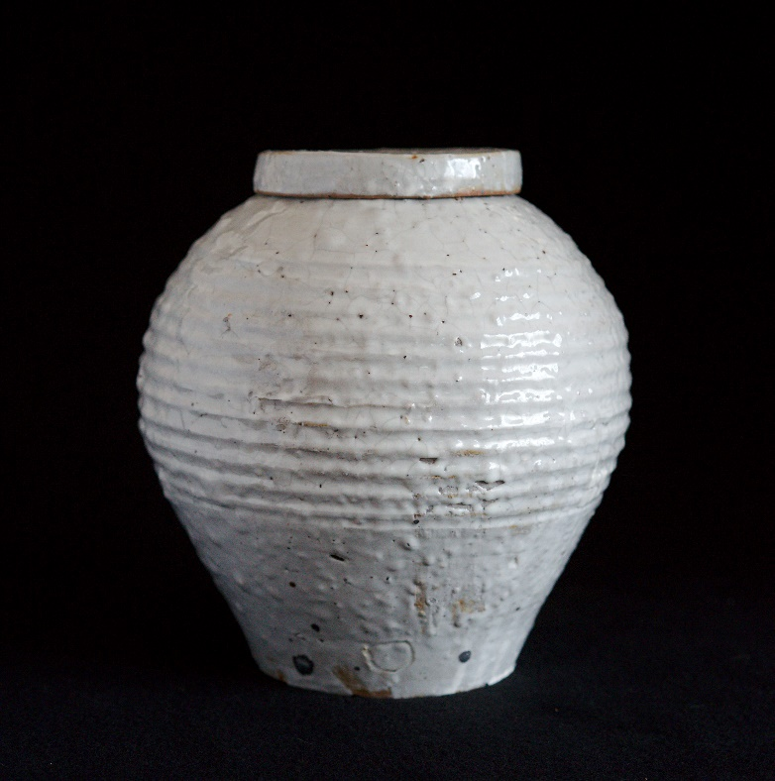
The subject of the exhibition is cinerary jars, but it is about the inner life of human beings. Julian Stair and Rob Barnard occupy a rather unique position in the ceramics field: not only are they makers, but also writers who have argued in countless articles about pottery’s ability to simultaneously operate on numerous levels to connect with our inner lives. They have sought in their work to restore the connection between works of art and the ordinary events, burdens, and suffering that make up the human experience. They are unapologetic about employing conventional pottery forms and the traditional role they play in everyday life as a vehicle for aesthetic expression. Neither believes that “art” lives in a separate, exclusive, and arcane realm, cut off from any relationship to the material aims and aspects of every other form of human struggle and accomplishment. Theirs is an emotional art that nourishes our inner life and offers us comfort, joy, and solace in moments of need. In their work one can see how they are acutely aware of pottery’s unique ability to interact with human beings in an intimate manner. This is, in fact, how pottery has informed and shaped their inner lives and is what has made them advocates for pottery as unique artform.

English potter Julian Stair and American Potter Rob Barnard have been making pots for combined total of over 90 years. In the early 1980’s Stair spent six months working with Barnard in Timberville, Virginia. Although they physically approach their work from entirely different perspectives, both artists have consistently emphasized the multivalent role of pottery in contemporary society. This exhibition of cinerary jars is another illustration of their investigations into how pottery is able connect with the inner lives of individual’s through use.

Stair has been involved in this idea of cinerary jars, death and containment for the last fifteen years. In an exhibition entitled “Quietus”, which toured Great Britain he created 130 works that included cinerary jars and life size sarcophagi.

For Barnard the cinerary jar was another subject/form in an array of multifaceted pottery forms he employs as a vehicle for the communication of complex ideas and emotions that transcend the seemingly mundane and commonplace nature of the pottery objects themselves.

The second exhibition, "Cub Creek: Twenty Years Together,” will highlight the diverse work of residents and founding members and heighten awareness of the only residency program exclusively for the ceramic arts in the Mid-Atlantic region. Located in Appomattox, Virginia, the Cub Creek Foundation for the Ceramic Arts hosts workshop and educational events and offers a year-long supportive residency in a rural environment. Cub Creek’s facilities have attracted young ceramic artists from around the world. Several foreign residents have stayed in the Atlantic region and contribute significantly to the vitality of ceramic arts here as teachers and professionals. Workshop presenters at Cub Creek, including Resident Director John Jessiman, represent a virtual who's who of important figures in the field. The exhibition will be a critical reflection of the abiding respect, affection and enthusiasm for the ceramic arts that Cub Creek embodies and promotes. “Cub Creek: Twenty Years Together” will be on display March 24-29.
“Inner Lives” is comprised of 16 jars (8 from each artist) and will take place at the Branch Museum of Architecture and Design in March of 2020. The Branch Museum is located at 2501 Monument Avenue in Richmond, Virginia's historic Fan District. The Branch is a not-for-profit organization that inspires current generations to appreciate, support and create exemplary architecture and design. The Branch is dedicated to the advocacy and stewardship of our rich regional heritage and invites the public to envision a world enriched by architecture and design. The Branch is open to the public Tuesday-Friday 10 a.m.-5 p.m.; Saturday 10 a.m.-4 p.m. and Sunday 1-5 p.m. Learn more at www.branchmuseum.org.

