NEWS RELEASE
Date: October 11, 2019
Contact: Jennie Dotts, 804.370.6565; estave@branchmuseum.org

IMPORTANT RENAISSANCE TAPESTRY RETURNS TO BRANCH MUSEUM
A Highlight of Centennial Celebration, Dec. 19th
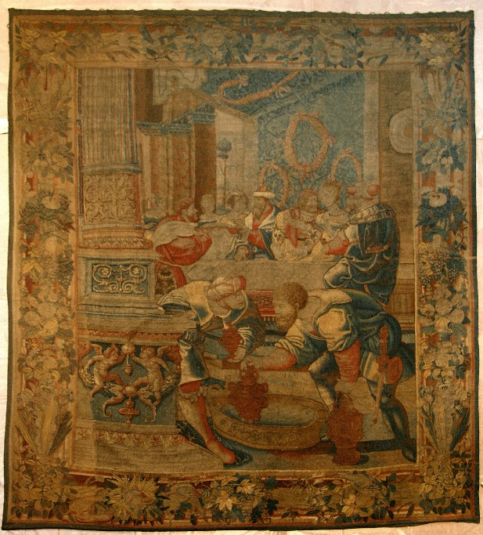
Ever on the lookout for Renaissance-era treasures, Virginia-born art collector John Kerr Branch purchased an exceptional 16th C. tapestry in Europe early in the 20th C. He later built a Tudor-style home in Richmond to house the 14 ft x 10 ft tapestry, along with his growing collection. His home, now the Branch Museum of Architecture and Design, 2501 Monument Ave., welcomes the return of this important Flemish tapestry dating from 1535-1540. On loan from his descendants, the Dotts’ family, the tapestry will be reunited with the house and on display to the public in December, marking the centennial of the Branch House completion in 1919. The tapestry’s journey across Europe --from weavers and artists in the Netherlands to European courts to auction houses--- and, finally, to Richmond is literally biblical, as is its subject: the Old Testament story of the marriage of Jacob and Rachel.
The Story of Jacob was a popular subject for Flemish Renaissance tapestry design in the 16th C. Jacob, called Israel, was the traditional ancestor of the people of Israel. Through deception he received his brother’s birthright. While escaping his brother’s wrath, he fell in love with Rachel. Rachel and Jacob’s path to the altar was operatic, to say the least, involving a dark tent, a substitute bride, and a love triangle.
All of this, and more, are intricately detailed in a narrative series of tapestries designed by Bernard van Orley, arguably the most important and influential Flemish artist of his generation. After the success of the original series tracing the sprawling story of Jacob, subsequent editions were reproduced. One ended up in the collection of Henry VIII of England. Another, in that of King Sigismund Augustus of Poland. Scholars have been piecing together the fragmented history of six possible editions.
What all editions have in common are: the theme (Jacob), the designer (Orley), the weaver (Willem de Kempeneer), and the fabric (silk and wool). Only the original set of tapestries –upon which the others are based—include gold- and silver-wrapped threads. The Branch tapestry, which includes precious metal-wrapped threads, is thought to be part of the original set, commissioned by Holy Roman Emperor Charles V. This much-prized Story of Jacob set of tapestries is recorded in the collection of Charles’ son, Philip II of Spain.
It took many tapestries in a single set to illustrate the adventures of Jacob, who had 13 children and lived to be 147 years old. The Branch tapestry-- The Marriage of Jacob and Rachel --depicts a climactic moment in his tormented timeline.
“The tapestry’s return represents a happy reunion, especially because my great-grandparents built the house 100 years ago to house this beautiful work of art and others like it. It personalizes the Branch Museum and will help tell the story of who built the house and why. It’s also a terrific example of the principle of decorum, that is, appropriate decoration for specific rooms dedicated to a particular use. In this case, an art work depicting a marriage feast will hang in the original dining room of the Branch House,” says Walter Dotts, whose late mother Zayde Rennolds Dotts inherited the tapestry.
The public will have its first opportunity—in this century—to see the tapestry at the Branch House, when it will be introduced during the Centennial Celebration, December 19th. The Branch House was built as a winter holiday house and the family spent its first Christmas there in December 1919. For details about the Centennial Celebration visit https://branchmuseum.org/ or call 804.655.6104.
To Penny Fletcher, Executive Director of the Branch Museum: “The centennial year has been about ensuring the future of the museum and the next hundred years of the house. This tapestry is evidence of the staying power of superb design and construction, an apt reflection of The Branch Museum’s mission.”

