Architecture Camp 2018
Summer 2018 At the Branch Museum of Architecture and Design
This weeklong program immerses campers in the world of architecture and design. The city will be their workshop as they visit architectural landmarks old and new, meet architects and designers, learn technical skills, and participate in hands-on building challenges. Camp will culminate in an exhibition of student work at the Branch Museum Fall 2018.

Register for: June 25-29 -- for rising 6th - 8th graders
Register for: July 9-13 -- for rising 6th - 8th graders
Register for: July 23-27 -- for rising 2nd - 5th graders
Register for: August 6-10 -- for rising 2nd - 5th graders
Register for: August 13-17 -- for rising 6th - 8th graders
Architecture Camp consists of exciting field trips and building challenges in which students will investigate approaches to real-world problems. Campers will become acquainted with The Branch House and Richmond's many neighborhoods through interactive tours and activities. As they explore, campers will be introduced to architects, designers, and other building systems professionals. Campers will practice observing, sketching, presenting, and building at various scales. They will use their newly learned skills in design challenges that relate to our built environment and our city. Students will complete camp with a new understanding and appreciation of the built environment around them and how they can change it.
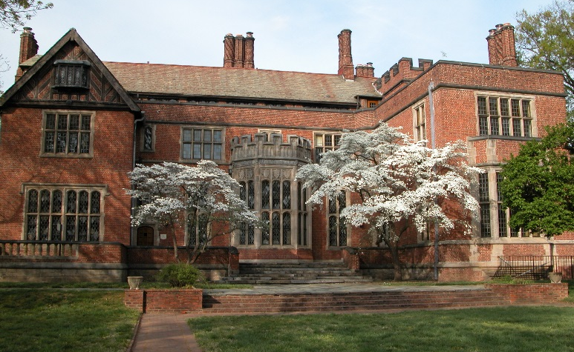
Questions? Ready to register? Contact mloustaunau@branchmuseum.org
The Branch Museum | 2501 Monument Avenue, Richmond, VA | www.branchmuseum.org
The Branch Museum elevates awareness of the transformative power of architecture and design.

