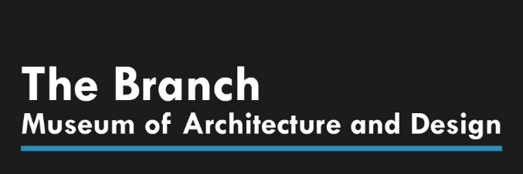

Museum Education Programs Intern
The Education Programs Intern provides support to The Branch Museum’s educational events and Architecture Camp. The Educations Programs Intern will help conduct and lead students through Architecture Camp, work alongside the program coordinator, and help prepare for upcoming educational events.

Responsibilities
- Primarily working alongside the camp coordinator to help lead and assist students through camp activities
- Assist in teaching students about architecture and design
- Help watch over students on camp tours
- Help to prepare necessary educational materials
- Assist in the setup of the Architecture Camp Exhibit
- Other duties as assigned

Requirements: An interest in the education of elementary and middle school students. Exhibits a great sense of responsibility and has a self-starter personality. Must be energetic and not afraid to step in! Most importantly, must be comfortable with children.

A background in working with children is a plus, but not a must.

Schedule:
The schedule will follow our Architecture Camp Schedule over the Summer of 2018 and the following weeks after that prepare for the Architecture Camp exhibit.

Architecture Camp Schedule:
June 25-29 — for rising 6th – 8th graders
July 9-13 — for rising 6th – 8th graders
July 23-27 — for rising 6th – 8th graders
August 6-10 — for rising 2nd – 5th graders
August 13-17 — for rising 6th – 8th graders

